**MAHARASHTRA STATE BOARD OF TECHNICAL EDUCATION,**

**MUMBAI**

Shri Vishweshwar Shikshan Prasarak Mandal’s

Vishweshwarayya Abhiyantriki Padvika Mahavidyalaya,

Almala

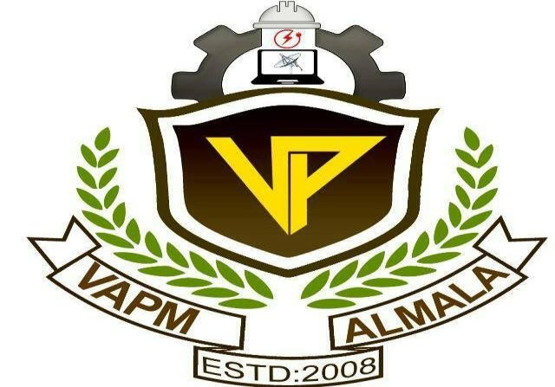

# Certificate

This is to certify that, Mr. Omanand Prashant Swami, Mr. Amay Nitin Devshatwar and Mr. Somesh Mahadev Bharbade students of our institute from **Second** year **Computer Engineering (CO3I)** have/has successfully completed the micro project report on **“Design a Rotating Fan”** of course **“Computer Graphics (22318)”** as part of curriculum by the Maharashtra State Board of Technical Education , Mumbai.

For partial fulfillment of “**Diploma in Computer Engineering**” during the academic year 2022-23.

GUIDE HOD

Mr. Kazi A.S.M Mr. Lokare A.P

PRINCIPAL

Mr. Dharashive P.S

**MAHARASHTRA STATE BOARD OF TECHNICAL EDUCATION,**

**MUMBAI**

Shri Vishweshwar Shikshan Prasarak Mandal’s

Vishweshwarayya Abhiyantriki Padvika Mahavidyalaya,

Almala.

Micro-Project Report On

**“Design a Rotating Fan”**

Submitted By

Enrollment No Name of Student

2110950050 Mr.Omanand Prashant Swami

2110950088 Mr.Amay Nitin Devshatwar

2110950103 Mr.Somesh Mahadev Bharbade

Under the Guidance of

Mr. Kazi A.S.M



Department of Computer Engineering

Academic Year-2022-23